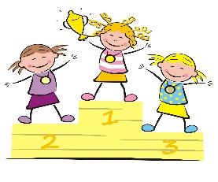
Snacks and Goodies shopping list
This Photo by Unknown Author is licensed under CC BY-SA-NC
Block of Ice-cream & wafers
2 packs of jelly snakes
Multi-pack of popcorn
Strawberries & dipping chocolate
Mi-Wadi (flavour of your choice)
Blowing Bubbles
Water pistols
Party bags
Paper / Plastic cups

Recipes

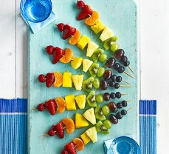
Rainbow Fruit Skewers
https://www.bbcgoodfood.com/recipes/rainbow-fruit-skewers

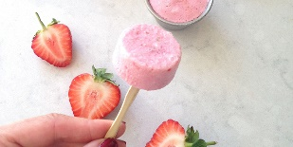
Easy Ice Lollies – 5 ideas
https://www.bbcgoodfood.com/howto/guide/five-easy-ice-lollies

Edible Prizes!
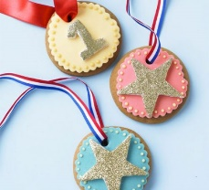
Medal Cookies
https://www.bbcgoodfood.com/recipes/medal-cookies

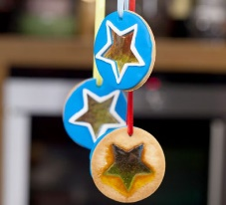
Star Medal Biscuits
https://www.bbcgoodfood.com/recipes/go-jetters-star-medal-biscuits

