Here are lots of activities for you to include in your Sports Day thanks to the Sligo Education Centre and the Move Well, Move Often program.
There are links to videos for most of the activities.


Activities
- Running games
- Kicking games
- Throwing games
- Balancing games
- Landing games
- Traditional School Sports Day games

Here is a planner to help you plan your day.
SPORTS DAY PLANNER
Event | Time | Results

A sports day is always better with some good music so here is a Spotify playlist if you wish to use it. https://open.spotify.com/playlist/7t02bxdFRuJHD8xSGyF8tD?si=FHOcL62uRS6JQw8I_By1lg

Running Games

Traffic Lights

Invite children to find a space in a large open playing area where they are not in
contact with anyone else. On a signal, children move around the playing area in

response to the following commands.
This Photo by Unknown Author is licensed under CC BY-NC
- Red: stop
- Amber: walk
- Green: run
You can also turn it into a game of moving statues if you like.
(Ref - PDST MWMO Book 1)
https://youtu.be/Uj9_pdx_vEA

Rock, Paper, Scissors tag

This game is played in pairs, standing apart and facing each other. All pairs line up along a centre line with a safety line positioned around twenty metres behind both sets of participants. Each pair begins by performing a rock-paper-scissors routine.
(A rock is a closed fist, paper is a flat hand, and scissors are the index and middle fingers in a cutting position. Paper always covers rock, rock breaks scissors, and scissors cut paper)
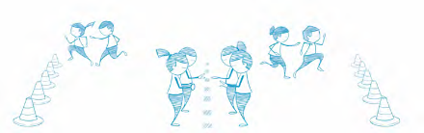
To determine a winner, pupils count to three and form a rock, paper, or scissors. The winning pupil then chases their partner toward their safety line, attempting to tag them before they are safe. Line up again and repeat the activity.
(REF - PDST MWMO Book 2)
https://youtu.be/oYCPKHFvveM

Kicking Games

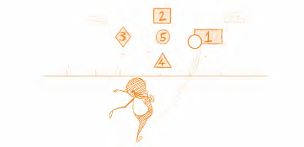
Kick to Score
Draw or stick target areas at various heights on a wall. Points should be placed in the centre of each target from one to five. Arrange pupils in groups of three or four. Pupils are given a score to achieve, e.g. ten. Groups must hit the targets on the wall to achieve that score.
https://youtu.be/XCGol4Y2Txk

Rebound Ball

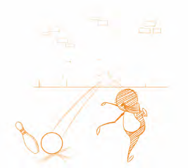
Arrange pupils in groups of four with one cone/skittle and one football each. The first pupil places their cone three to five metres from the wall within their designated playing area. This pupil then places their ball next to the skittle and kicks it, aiming to hit the skittle on the rebound. If the cone is hit, the cone is then moved one metre further away from the wall. A goal line can be set ten metres from the rebound wall. A goal is scored when a pupil has successfully progressed the cone, metre by metre, back across the goal line. (REF - PDST MWMO Book 2)
https://youtu.be/KHoYnuwCo0c
Throwing Games

Knock ‘em Down Pinball
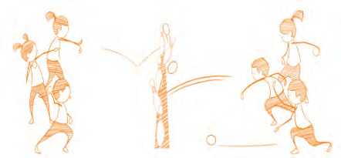
Arrange pupils in groups of four or pupils can play in pairs or singly. Pupils line up fifteen metres apart, either side of a line of skittle targets as shown. Pupils could also use cans of Beans or empty cereal boxes. Groups take turns to roll a ball, trying to knock over a target in the middle. If a pupil successfully knocks over a skittle, they can claim this skittle and bring it over to their side. Continue playing until all of the skittles have been claimed.
(REF - PDST MWMO Book 1)
https://youtu.be/_BwUf9mXm4Y

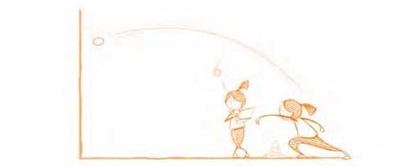
Tennis ball Challenge

Pupils work in pairs, one throwing and the other counting. The aim is to throw the ball against the wall and catch it again as many times as possible in thirty seconds. For safety reasons ensure that groups are spaced at least three metres apart.
(REF - PDST MWMO Book 2)
https://youtu.be/KxD8V6xvsLk

Bowling
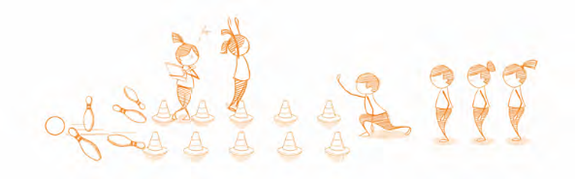
Use cones to set up a bowling lane approximately five metres in length for each group. At the end of the bowling lane place five skittles as targets. Each bowler has three balls to knock over as many skittles as possible. All bowlers take a turn and then Replaced the knocked skittles. Keep your score. The pupil that knock over the most skiles wins. Increase difficulty by increase the distance between the thrower and the skittles or decreasing the width of the lane.
(Ref - PDST MWMO Book 3)

https://youtu.be/cg9gURRP63c

Landing Games

Jack be Nimble
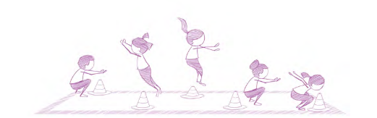
Arrange the children in pairs and scatter the cones randomly around the playing area. Pupil A chants the rhyme below for pupil B who must jump off two feet over the cone (the candlestick) and attempt to land safely on the other side of the cone. Pupil B should jump over three cones while pupil A is saying the rhyme: ‘Jack be nimble, Jack be quick, Jack don’t land on the candlestick’. After pupil B has completed three jumps and three landings, swap roles and play again.
(REF – PDST MWMO Book 1)

https://youtu.be/nllViOJhowc

Jockeys up

Arrange children in pairs (horse and jockey) and invite them to find their own space in an open playing area. On a signal the children carry out the following movements:
- Under the bridge - the jockey crawls under the horse's body.
- Long way to town - the jockey jumps clockwise in a circle around the horse.
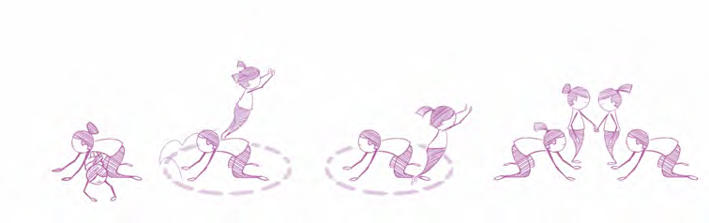
- Short way to town - the jockey jumps an-clockwise around the horse.
- Trade your horse - all jockeys find a new partner.
Ensure partners regularly switch roles.
(REF - PDST MWMO Book 3)

Balancing Games

Walk the Line
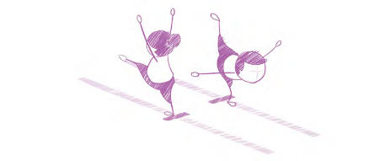
Pupils walk along a line on the floor (this could be a line painted on the floor, a strip of tape or a line of spot markers). Invite pupils to: • turn fully around in the middle without losing balance or toppling off the line • complete the task with their eyes closed (in pairs with one pupil acting as a guide) • hold a shape for a count of three as they balance on the line.
(REF - PDST MWMO Book 1)
https://youtu.be/y_v3a56R1DE

Wheelbarrow Races
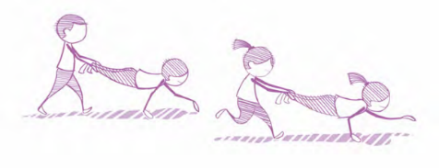
Arrange pupils in pairs. Set up two lines of cones, twenty metres apart and invite pupils to find some space along the line. One pupil adopts the high plank position and their partner lifts their legs below the knee. The pupil holding the high plank moves their hands to go forward, with their partner carrying their legs behind. Invite pupils to me themselves travelling from one cone to another.
(REF - PDST MWMO Book 3)
https://youtu.be/I9X8PowsdAU
Traditional Sports Day Games and Activities

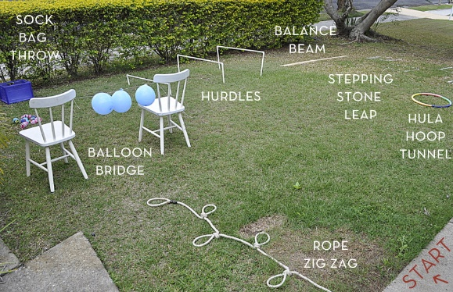
Obstacle Course
Invite pupils to set up and run their own obstacle course with parameters as set out below. Use any equipment available - household or otherwise. Invite pupils to do the obstacle course, time themselves and try to beat their original time.
(photo Ref - Beafunmum.com)

https://youtu.be/sXjDO9G2JQY

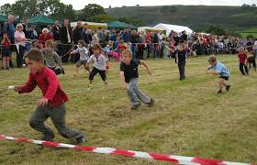
Egg and spoon / spud and spoon race.
Each pupil gets a spoon and an egg (hardboiled or plastic). Each team must carry their egg on their spoon from the starting line to a turnaround point and back again. Then, the egg is passed off to a teammate who takes their turn. If the egg is dropped, the pupil must stop and retrieve it.
Ref( Photo - Wikipedia.com)

https://youtu.be/4yMS0IuPZD0

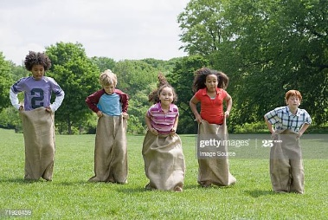
Sack Race
Each pupil puts both legs into sack and hops around a cone, or some marked point, and back, tagging the next person in line. Then, the next pupil in line gets into the sack and repeats the once-around the cone course. The Pupil or team to the finish line wins.
(REF - Photo Getty images)

https://youtu.be/A7XYZ__HL6Q

Some other ideas for Sports Day Activities
- Hula hoop challenges
- Space hopper race
- Relay race
- Balloon games
- Bean bag throwing competition
- Five-a-side football
- Dribbling a football around cones
- A mini triathlon of different skills

